**How to Add User Access in DealerAcctg System**

**STEP 1:**

Make it sure you add the user account in Inventory System before you can add a user access in DealerAcctg System.

First you may log-in DealerAcctg System, go to Admin Tools Menu and select User Access, see figure 1.0

**FIGURE 1.0**

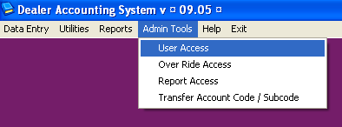

**STEP 2:**

In User ID Text field, you may type the employees id number or press function F5 to search the employees name, press function F5 to select.

Click Edit Access Button, then you may select the access based on your list for the user by ticking the box then click Save Button and Close. See figure 2.0

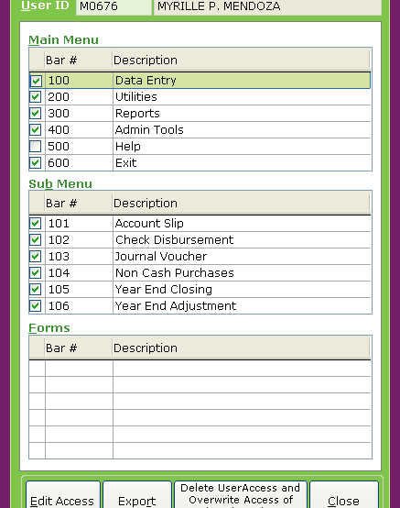**FIGURE 2.0**

**STEP 3:**

For Admin or Manager/Supervisory level, you may add the override access for the purpose of void, post, unvoid, unpost access.

Select Admin Tools Menu, select Override Access, in User ID Text field, you may type the employees id number or press function F5 to search the employees name, press function F5 to select.

Click Edit Override Access Button and then you may select the access based on your list for the user by ticking the box then click Save Button and Close. See figure 3.0

**FIGURE 3.0**

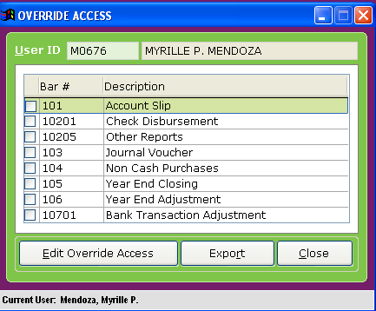

**STEP 4:**

To add Report Access, go to Admin Tools menu and select Report Access.

In User ID Text field, you may type the employees id number or press function F5 to search the employees name, press function F5 to select.

In Report Form field, type 301 for report index.

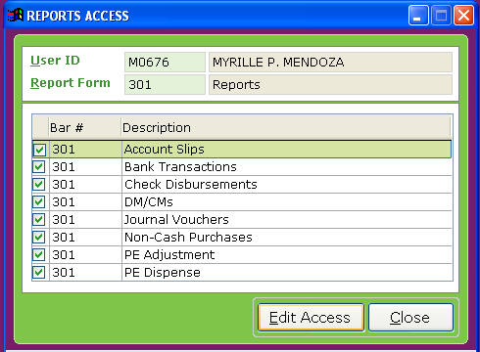Click Edit Access Button, then you may select the reports based on your list for the user to view by ticking the box then click Save Button and Close. See figure 4.0

**FIGURE 4.0**